Docker

* Used to make the process of deployment very easy and efficient and resolves a lot of issues related to deploying applications.
* It’s a tool(container platform) that is used to deploy and run applications using containers.
* Containers allow a developer to package up an application with all the libraries and other dependencies and ship it allout as one packages.
* Virtualization vs Containerization, In virtualization space and other resources are fixed so it’s a heavy weight and memory waistage will be there. But in containerization memory and other resources are not fixed that wil consume based on requirements so it’s a light weight and very fast.
* Here we build and configure our application only once and put into container and application inside a container can run on any system that has docer installed.

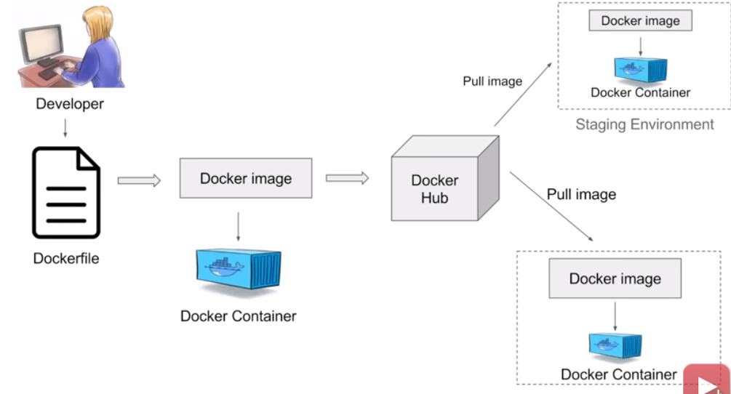

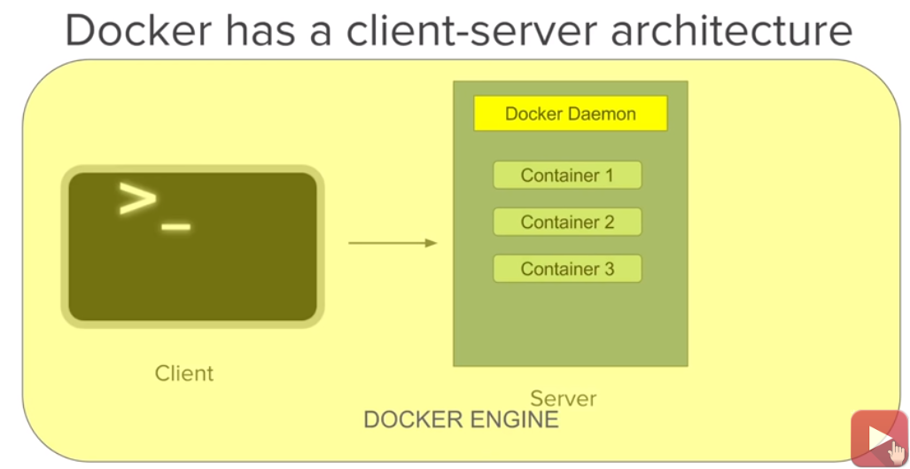

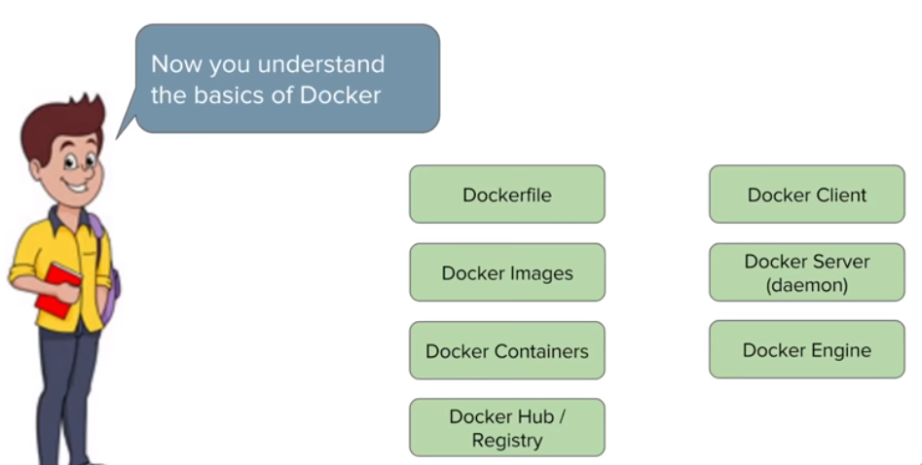

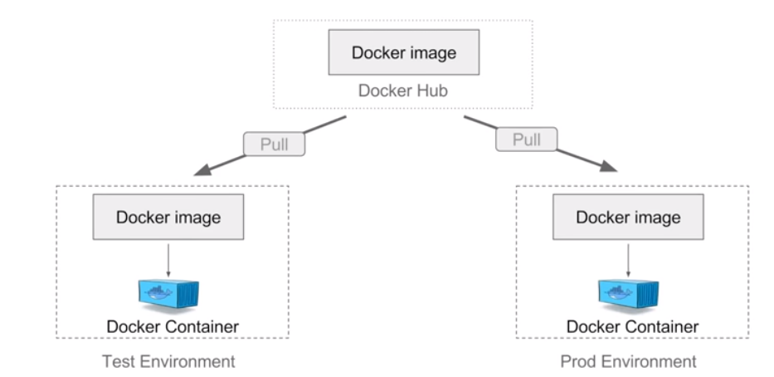

Installer Command

>sudo yum –y update

>sudo yum install –y docker

>docker

>docker –version

>docker info

>sudo service docker start

>sudo usermod –a –G docker ec2-user

>docker images

>docker ps

>docker ps –a

>docker run docker-spring-boot

>docker images

>docker ps –a

>sudo service docker stop

>sudo yum remove docker

Create Spring-Boot App to Image

Spring-boot_app>docker build –f Dockerfile –t docker-spring-boot .

Spring-boot_app >docker images

>docker run –p 8085:8085 docker-spring-boot

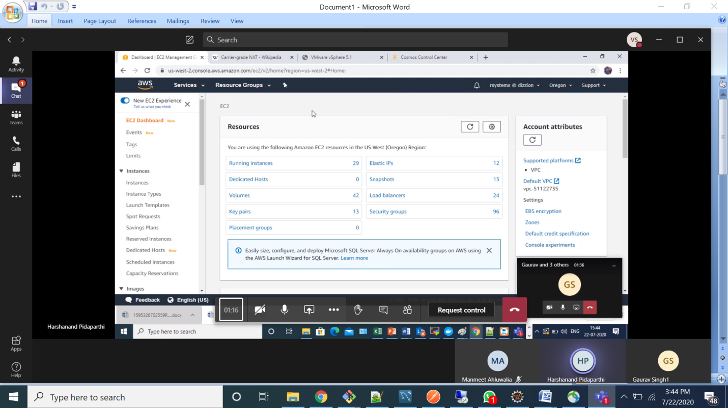

Os to run java will

Install java and application---pod

Workstation—

Cluster--nodes—pod

Create Cluster

Create vpc

EKS->cluster

